|  |  |  |  |
| --- | --- | --- | --- |
|  | **Jump Height (m)** | **Maximum Force (N)** |  |
| **Single Mass Model** | 0.2055 | 1.755 | 18cm Moment Arm  300 RPM Motor |
| **Unity Simulation** | 0.0157 | 1.755 |
| **Experiment** | 0.0314 | 1.320 |
| **Single Mass Model** | 0.2009 | 1.970 | 5 cm Moment Arm  1000 RPM Motor |
| **Unity Simulation** | 0.0559 | 1.970 |
| **Experiment** | 0.002 | 0.68 |

A close up of an object

Description generated with very high confidence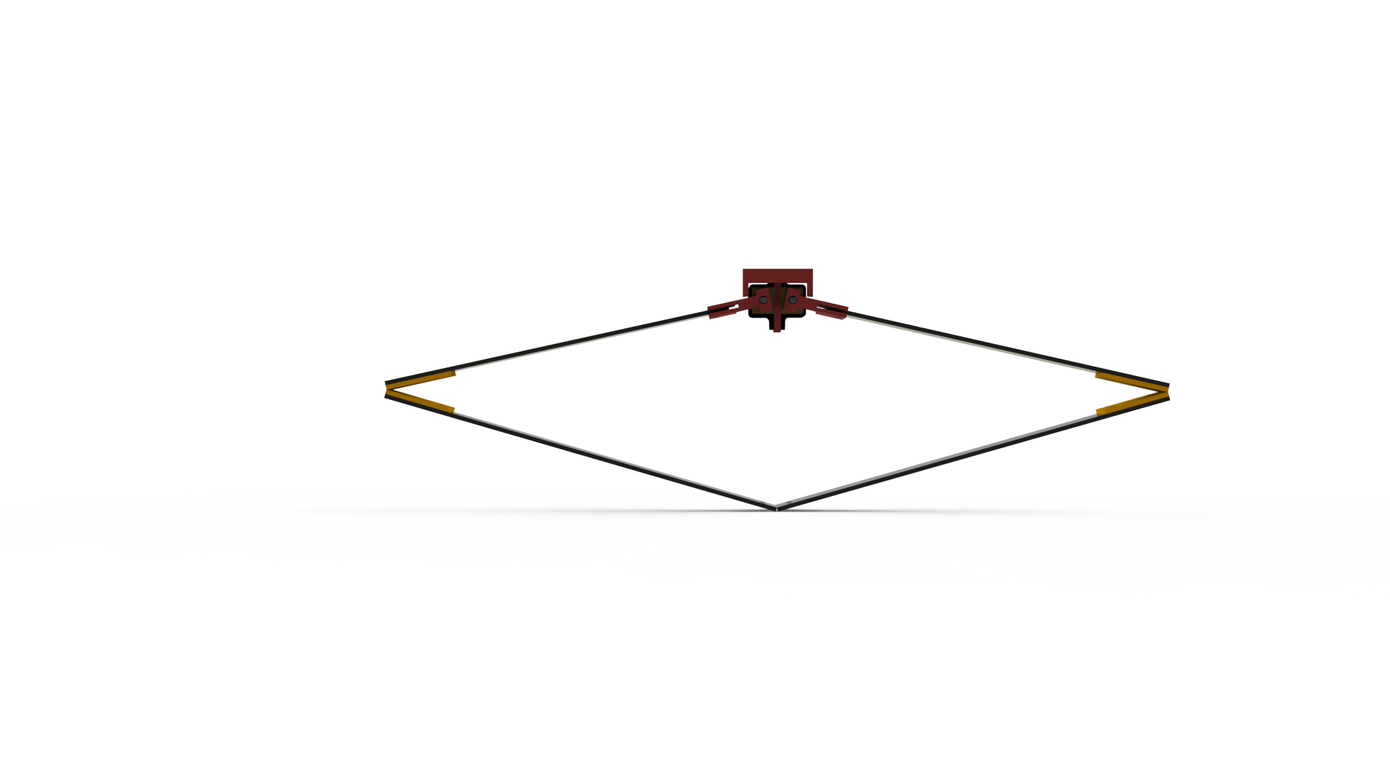

Introduction

Background

* Table comparing previous work?

description of method

design process

* + Assumptions?/design space
  + Picture of prototype?—dxf lines

Model

* + Energy storage and projectile phases
  + Thought exercise
  + Cantilevered beam deflection & embedded force measurement
  + Image of simplified system with labels

Simulation

* + Plots of jump height vs factors

Experiment

* + Plot of trajectory, force, and current of single jump(s)
  + Image of test setup
  + Application of force feedback?
  + **Find way to show energy**

results & discussion

* Jump height points superimposed on simulation plot
* Compare force of single jump with sim
* Verify embedded force sensing vs plate?

conclusions and future work